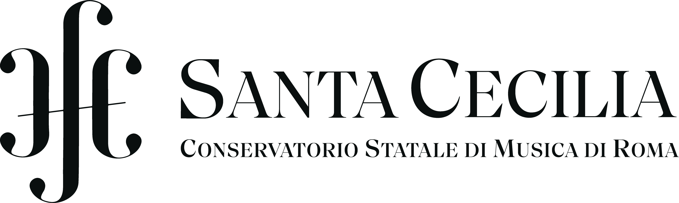

Erasmus + Mobility
Student Application form
All applications for exchange programmes must be made through
the Erasmus+ Coordinator in the sending institution
Last/family name:
First name:

Applying to Receiving Institution
Receiving institution: | Host institution’s name
Principal study subject (instrument or subject of thesis) at The Receiving Institution
Study cycle during the exchange period | Bachelor (1st) ☐ |  | Master (2nd) ☐ |  | Doctorate (3rd) ☐
Study period according to The Receiving Institution’s academic calendar: | 1st Semester ☐ | 2nd Semester ☐ |  | Academic Year ☐ |  | Other Period (i.e.Term) ☐
Academic year: | Academic year student applies for

Sending Institution
Name: | Name | Administrative Unit: | International Relations Office
Institutional code:  (if applicable) | Institutional Code | Erasmus+ Coordinator: | Contact Person
Address: | Address | E-mail : | E-mail
Country : |  | Phone : | Phone (incl. country code)

Student
Last/family name (s): |  | Last name (s) | First name (s): |  | First name(s)
Date and place of birth: |  | Date and place of birth | Nationality: |  | Nationality
Sex [M/F]: |  | M/F | Phone: |  | Phone (incl. country code)
Current address |  | Current address | Permanent address  (if different): |  | Permanent address
Current address is valid until: |  | Valid until | Emergency contact: |  | Name, E-mail, Phone
E-Mail: |  | E-mail
Current Studies (at Sending Institution):
Field of Education ISCED Code: | 0215 (Music and Performing Arts)
Study programme (relevant for your study stay): | Study programme
Principal study subject: | Principal study subject
Study cycle: |  |  |  | Study year: |  | 1st ☐ | 2nd ☐ | 3rd ☐ | 4th ☐
Duration of the Study Programme: | Number of years

Study Period
Period of study |  | Duration of stay (No. of study months) | Number of expected ECTS credits | Preferred professor(s) at Receiving institution for the main subject (if any)
dd/mm/yy  (or month/year) | dd/mm/yy  (or month/year)

Desired Courses at Receiving Institution (Preliminary Learning Agreement)
Course component code (if any) | Course component title  (as indicated in the course catalogue) at Receiving Institution | Semester (autumn / spring  or term) | Number of ECTS credits to be awarded by Receiving Institution upon successful completion
Total number of ECTS

Application Package:
1. Recording or Portfolio for Audition
If Receiving institution requires you to send in a (certified) recording of your audition repertoire, please ask your teacher of your main subject to certify by signing that the recording is your own performance
List of pieces performed on your Recording (music performers) and/or scores indicated in your Portfolio (for composers):

2. Motivation
Please attach your motivation letter

3. Transcript of Records
Please attach your Transcript of Records (if requested by Receiving Institution)

4. Curriculum Vitae
Please attach your CV (if requested by Receiving Institution)

Student’s Language Skills

Mother tongue:
Please indicate your language skills other than mother tongue:
1. Language: Language 1 | Limited A1 ☐ A2 ☐ | Moderate B1 ☐ B2 ☐ | Fluent C1 ☐ C2 ☐
2. Language: Language 2 | Limited A1 ☐ A2 ☐ | Moderate B1 ☐ B2 ☐ | Fluent C1 ☐ C2 ☐
3. Language: Language 3 | Limited A1 ☐ A2 ☐ | Moderate B1 ☐ B2 ☐ | Fluent C1 ☐ C2 ☐
I am aware of the obligation to pass the online language test (via OLS) before my studies abroad, and I am interested in improving my language skills if recommended |  |  |  | ☐

Previous Studies in Erasmus Programme

Have you already been studying/working abroad as ERASMUS student/trainee? |  |  | Yes ☐ | No ☐
If “Yes”, please indicate: | Receiving Institution: | Former host institution’s name | Former host institution’s name | Former host institution’s name
 | Study cycle | Bachelor (1st) ☐ | Master (2nd) ☐ | Doctorate (3rd) ☐
 | Duration of stay (months) | Duration of stay (months)

Signatures of Sending Institution
Student: | Name, surname |  | Date: | Signature date
Professor/Tutor  (of the main subject): | Name, surname |  | Date: | Signature date
Head of Department: | Name, surname |  | Date: | Signature date
Erasmus + Coordinator: | Name, surname |  | Date: | Signature date

NOTES FOR GUIDANCE
General Information
All enquiries and applications for exchange programmes must be made through the responsible Erasmus Coordinator in your sending/home institution. To facilitate general procedures, please use e-mail until the point of mutual confirmation/signatures.
Application form and deadline
Please complete the form as fully and as clearly as possible. The Coordinator will inform you about the application deadline for your preferred receiving/host institution(s).
Other forms
Some institutions may require extra documentation with your application; you may for example be asked to complete a second application form and/or apply only for your study abroad.

Transcript including full details of previous and current higher education study. This has to be issued by the sending institution, not to be mistaken with the final ‘transcript of records’ which will be issued by the receiving institution at the end of the exchange period.
Language competence You will normally be expected to have some proficiency in the language used for tuition in the receiving institution and you will gain most benefit from your exchange if you have some proficiency in the country’s native language. Language skills: This information is only meant as a preliminary rating to assess the level of language proficiency. The actual level will be determined after the student’s Erasmus+ nomination by the first OLS assessment. To facilitate your rating, the given options may be regarded in rough relation to the reference levels of the Common European Framework of Reference for Languages (CEFR – see http://europass.cedefop.europa.eu/en/resources/european-language-levels-cefr): A1 (limited) – C1/2 (fluent).

